➛ HTML QUESTIONS →

**( 30 Marks )**

* 1. <!DOCľYPE html> is it a tag of html? If not, what is it and why do we use it?

**(1 Maíks)**

* 1. Explain Semantic tags in html? And why do we need it? ( **2 Maíks)**
  2. Diffeíentiate between HľML ľags and Elements? **(2 Maíks)**
  3. Build Youí Resume using HľML only **(5 Maíks)**
  4. Wíite Html code so that it looks like the given image Link **(5 Maíks)**
  5. What aíe some of the advantages of HsľML5 oveí its píevious veísions? **(2 Maík)**
  6. Cíeate a simple Music playeí using html only **(5 Maíks)**
  7. What is the diffeíence between <figuíe> tag and <img> tag? **(1 Maíks)**
  8. What’s the diffeíence between html tag and attíibute and give example of some global attíibutes? **(2 Maíks)**
  9. build ľable which looks like the given image Link **(5 Maíks)**

➛ CSS QUESTIONS →

## ( 60 Marks)

* 1. Whats Box Model in CSS & Which CSS Properties are part of it ? **(2 Marks)**
  2. What are the Different Types of Selectors in CSS & what are the advantages of them?

## (2 Marks)

* 1. What is VW/VH & How its different from PX? **(2 Marks)**
  2. Whats difference between Inline, Inline Block and block ? **(3 Marks)**
  3. How is Border-box different from Content Box? **(2 Marks)**
  4. What’s z-index and How does it Function ? **(2 Marks)**
  5. What’s Grid & Flex and difference between them? **(5 Marks)**
  6. Difference between absolute and relative and sticky and fixed position explain with example. **(5 Marks)**
  7. Build Periodic Table as shown in the below image **(10 Marks)**

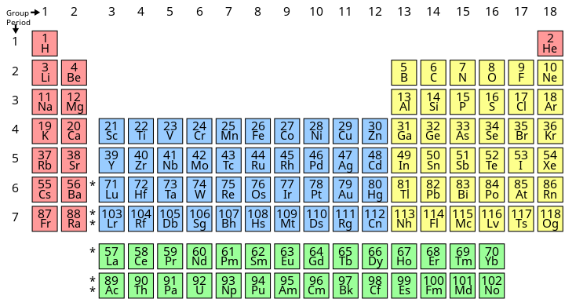

Q. 9 Build given layout using grid or flex see below image for reference . **(5 Marks)**

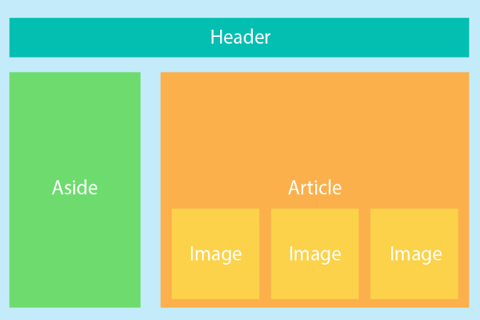

* 1. Build Responsive Layout both desktop and mobile and Tablet, see below image for reference ? **(10 Marks)**



* 1. Build Complete Homepage of Ineuron ( Link ) with responsiveness. **(10 Marks)**
  2. What are Pseudo class in CSS & How its different From Pseudo Elements? **(2 Marks)**

# ← JavaScript Questions →

## (40 Marks)

* 1. What is Hoisting in Javascript ? **(3 Marks)**
  2. What are different higher order functions in JS? What is the difference between .map() and .forEach() ? **(2 Marks)**
  3. What is the difference between .call() .apply() and .bind()? explain with an example **(2 Marks)**
  4. Explain Event bubbling and Event Capturing in JavaScript with suitable examples **(2 Marks)**
  5. What is function currying with example? **(2 Marks)**
  6. Explain execution context diagram of following code snippets, use white board to draw execution context diagram **(4 Marks)**

## Code Snippet 1 console.log('First');

**setTimeout(() => console.log('Second'), 0); console.log('Third');**

## Code Snippet 2

**console.log('First'); function secondCall() {**

## console.log('Second');

**}**

## setTimeout(secondCall, 2000); setTimeout(() => console.log('Third'), 0); console.log('Third');

* 1. What are promises? What are the different states of a promise? Support your answer with an example where you need to create your own promise. **(2 Marks )**
  2. What is ‘this’ keyword in JavaScript? explain with an example & create **(4 Marks)**
  3. Explain event loop Call Stack Callback queue and Micro Task queue in Your Words **(2 Marks)**
  4. Explain Debouncing and Create a project where you are using Debouncing **(5 Marks)**
  5. Explain Closures and Use cases of Closures **(2 Marks)**
  6. Create a Blog web app using JavaScript **(10 Marks)**
     + Fetch data from https://jsonplaceholder.typicode.com/posts and show it to ui
     + User can also add new blog
     + Add Delete functionality also

# ← React Questions →

## (50 Marks)

* 1. What’s React and What are the advantages of it? **(1 Marks)**
  2. What's Virtual Dom in React & What are the advantages of it? **(2 Marks)**
  3. Explain LifeCycle of React Components? **(1 Marks)**
  4. Whats the difference between between Functional Components and Class Components? **(1 Marks)**
  5. What are the hooks in React & Can we use Hooks in Class Components? **(2 Marks)**
  6. What are the LifeCycle method and the advantages of it? **(2 Marks)**
  7. What’s useState Hook & Advantages of it? **(2 Marks)**
  8. Explain useEffect & Advantages of it **(2 Marks)**
  9. Explain Context Api and create a minor project on it **(5 Marks)**
     + Create dashboard and with button on clicking on that change theme to dark and light
  10. Explain useReducer and Its advantages. **(2 Marks)**
  11. build a Todo Web App Using React and useReducer Hook**. (5 Marks)**
  12. Build A simple counter app using React **(4 Marks)**
  13. Build Calculator Using React Only **(4 Marks)**
  14. Build a Tic Tac Toe Game using Class Component of React **(5 Marks)**
  15. Explain Prop Drilling & How can we avoid it? **(2 Marks)**
  16. Create a task manager where user can create tasks and see his task **(10 Marks)**
      + Redirect him to task dashboard section after login
      + Use https://reqres.in/ api to authenticate user and redirect him to task manager dashboard where he can see his task and create

# ← Express Question →

## (50 Marks)

* 1. Create a simple server using Express and connect with backend and create an endpoint “/post” which sends 20 posts **(3 Marks)**
  2. Explain a middleware and create a middleware that checks is user authenticated or not then send data of post **(4 Marks)**
  3. Create a backend for blog app, where user can perform crud operations **(10 Marks)**
     + Add blog
     + Delete blog
     + Update blog
     + Replace blog
  4. What is the difference between authentication and authorization? **(2 Marks)**
  5. What is he difference between common JS and EJS module? **(2 Marks)**
  6. What is JWT and what we can achieve with that create a minor project with jwt **(5 Marks)**
     + Login and sign up
     + Add authentication using jwt
  7. What should we do with the password of a user before storing it into DB? **(2 Marks)**
  8. Whats event loop in NodeJS **(2 Marks)**
  9. Create a Full Stack Ecommerce website with all major functionalities. **(20 Marks)**

← Submission Process →

There are Two Types of Question Theory based Question and Project based (where you actually have to code)

First of all, You have to create an google doc, where you will add answers of all the questions

If you are attempting a question in which you have to write code, so create a repo push your code to repo and copy the link of repo and add into docs as shown below

*Eg. Answer. 6 JavaScript - > github repo link*

If you are attempting a theory based question then you have to add answer in same google docs as its

*Eg. Answer 1 JavaScript*

*Hoisting is JavaScript's default behavior of moving declarations to the top.*

Then submit that final link (google doc link which has all the answers)

## TOTAL MARKS - 230